|  |  |  |  |  |  |  |  |  |  |
| --- | --- | --- | --- | --- | --- | --- | --- | --- | --- |
| **SCHOOL OF COMPUTER SCIENCE AND ARTIFICIAL INTELLIGENCE** | | | | | **DEPARTMENT OF COMPUTER SCIENCE ENGINEERING** | | | | |
| **Program Name:** B. Tech | | | | **Assignment Type: Lab** | | | **Academic Year:**2025-2026 | | |
| **Course Coordinator Name** | | | | Dr. Rishabh Mittal | | | | | |
| **Instructor(s) Name** | | | | |  | | --- | | Mr. S Naresh Kumar | | Ms. B. Swathi | | Dr. Sasanko Shekhar Gantayat | | Mr. Md Sallauddin | | Dr. Mathivanan | | Mr. Y Srikanth | | Ms. N Shilpa | | Dr. Rishabh Mittal (Coordinator) | | Dr. R. Prashant Kumar | | Mr. Ankushavali MD | | Mr. B Viswanath | | Ms. Sujitha Reddy | | Ms. A. Anitha | | Ms. M.Madhuri | | Ms. Katherashala Swetha | | Ms. Velpula sumalatha | | Mr. Bingi Raju | | | | | | |
| **CourseCode** | | | 23CS002PC304 | **Course Title** | | AI Assisted Coding | | | |
| **Year/Sem** | | | III/II | **Regulation** | | R23 | | | |
| **Date and Day**  **of Assignment** | | | **Week6 – Friday** | **Time(s)** | | 23CSBTB01 To 23CSBTB52 | | | |
| **Duration** | | | 2 Hours | **Applicable to**  **Batches** | | All batches | | | |
| **Assignment Number: 11.5**(Present assignment number)/**24**(Total number of assignments) | | | | | | | | | |
|  | | | | | | | | | |
|  | **Q.No.** | **Question** | | | | | | ***Expected Time***  ***to complete*** |  |
|  | 1 | **Lab 11 – Data Structures with AI: Implementing Fundamental Structures**  **Lab Objectives**   * Use AI to assist in designing and implementing fundamental data structures in Python. * Learn how to prompt AI for structure creation, optimization, and documentation. * Improve understanding of Lists, Stacks, Queues, Linked Lists, Trees, Graphs, and Hash Tables. * Enhance code quality with AI-generated comments and performance suggestions.   **Task Description #1 – Stack Implementation**  Task: Use AI to generate a Stack class with push, pop, peek, and is_empty methods.  Sample Input Code:  class Stack:  pass  Expected Output:   * A functional stack implementation with all required methods and docstrings.   **Task Description #2 – Queue Implementation**  Task: Use AI to implement a Queue using Python lists.  Sample Input Code:  class Queue:  pass  Expected Output:   * FIFO-based queue class with enqueue, dequeue, peek, and size methods.   **Task Description #3 – Linked List**  Task: Use AI to generate a Singly Linked List with insert and display methods.  Sample Input Code:  class Node:  pass  class LinkedList:  pass  Expected Output:   * A working linked list implementation with clear method documentation.   **Task Description #4 – Hash Table**  Task: Use AI to implement a hash table with basic insert, search, and delete methods.  Sample Input Code:  class HashTable:  pass  Expected Output:   * Collision handling using chaining, with well-commented methods.   **Task Description #5 – Graph Representation**  Task: Use AI to implement a graph using an adjacency list.  Sample Input Code:  class Graph:  pass  Expected Output:   * Graph with methods to add vertices, add edges, and display connections.   **Task Description #6: Smart Hospital Management System – Data Structure Selection**  A hospital wants to develop a Smart Hospital Management System that handles:   1. Patient Check-In System – Patients are registered and treated in order of arrival. 2. Emergency Case Handling – Critical patients must be treated first. 3. Medical Records Storage – Fast retrieval of patient details using ID. 4. Doctor Appointment Scheduling – Appointments sorted by time. 5. Hospital Room Navigation – Represent connections between wards and rooms.   **Student Task**   * For each feature, select the most appropriate data structure from the list below:   + Stack   + Queue   + Priority Queue   + Linked List   + Binary Search Tree (BST)   + Graph   + Hash Table   + Deque * Justify your choice in 2–3 sentences per feature. * Implement one selected feature as a working Python program with AI-assisted code generation.   Expected Output:   * A table mapping feature → chosen data structure → justification. * A functional Python program implementing the chosen feature with comments and docstrings.   **Task Description #7: Smart City Traffic Control System**  A city plans a Smart Traffic Management System that includes:   1. Traffic Signal Queue – Vehicles waiting at signals. 2. Emergency Vehicle Priority Handling – Ambulances and fire trucks prioritized. 3. Vehicle Registration Lookup – Instant access to vehicle details. 4. Road Network Mapping – Roads and intersections connected logically. 5. Parking Slot Availability – Track available and occupied slots.   **Student Task**   * For each feature, select the most appropriate data structure from the list below:   + Stack   + Queue   + Priority Queue   + Linked List   + Binary Search Tree (BST)   + Graph   + Hash Table   + Deque * Justify your choice in 2–3 sentences per feature. * Implement one selected feature as a working Python program with AI-assisted code generation.   Expected Output:   * A table mapping feature → chosen data structure → justification. * A functional Python program implementing the chosen feature with comments and docstrings.   **Task Description #8: Smart E-Commerce Platform – Data Structure Challenge**  An e-commerce company wants to build a Smart Online Shopping System with:   1. Shopping Cart Management – Add and remove products dynamically. 2. Order Processing System – Orders processed in the order they are placed. 3. Top-Selling Products Tracker – Products ranked by sales count. 4. Product Search Engine – Fast lookup of products using product ID. 5. Delivery Route Planning – Connect warehouses and delivery locations.   **Student Task**   * For each feature, select the most appropriate data structure from the list below:   + Stack   + Queue   + Priority Queue   + Linked List   + Binary Search Tree (BST)   + Graph   + Hash Table   + Deque * Justify your choice in 2–3 sentences per feature. * Implement one selected feature as a working Python program with AI-assisted code generation.   Expected Output:   * A table mapping feature → chosen data structure → justification. * A functional Python program implementing the chosen feature with comments and docstrings. | | | | | | Week6 -Friday |  |

**Task 1: Stack Implementation**

**Prompt:**

Generate a Python Stack class with push, pop, peek, and is_empty methods using a list internally. Include proper docstrings for the class and each method and ensure the implementation is fully functional.

**Code:**

class Stack:

    """

    A class to represent a Stack data structure (LIFO - Last In First Out).

    """

    def __init__(self):

        """Initialize an empty stack."""

        self.items = []

    def push(self, item):

        """Add an item to the top of the stack."""

        self.items.append(item)

    def pop(self):

        """

        Remove and return the top element.

        Raises IndexError if stack is empty.

        """

        if self.is_empty():

            raise IndexError("Pop from empty stack")

        return self.items.pop()

    def peek(self):

        """

        Return the top element without removing it.

        Raises IndexError if stack is empty.

        """

        if self.is_empty():

            raise IndexError("Peek from empty stack")

        return self.items[-1]

    def is_empty(self):

        """Return True if stack is empty, else False."""

        return len(self.items) == 0

# ------------------ Testing the Stack ------------------

s = Stack()

s.push(10)

s.push(20)

s.push(30)

print("Top element:", s.peek())

print("Popped element:", s.pop())

print("Is stack empty?", s.is_empty())

print("Popped element:", s.pop())

print("Popped element:", s.pop())

print("Is stack empty?", s.is_empty())

**Sample Input\Output:**

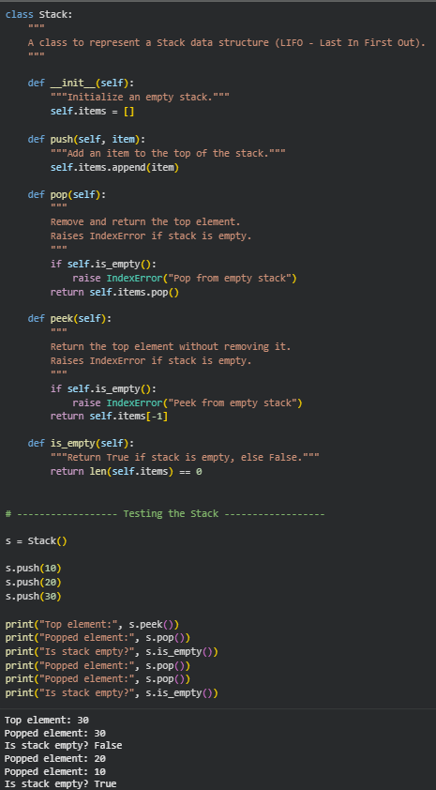

**Exaplanation**

1. The Stack class implements the **LIFO (Last In First Out)** principle.
2. Internally, it uses a Python list to store elements.
3. The push() method adds elements to the top of the stack using append().
4. The pop() method removes and returns the top element, raising an error if the stack is empty.
5. The peek() method allows viewing the top element without removing it.
6. The is_empty() method checks whether the stack contains any elements.

**Task 2: Queue Implementation**

**Prompt:**

Generate a Python Queue class implemented using a list that follows FIFO principle. Include enqueue, dequeue, peek, and size methods with proper docstrings and demonstration output.

**Code:**

class Queue:

    """

    A class to represent a Queue data structure (FIFO - First In First Out).

    """

    def __init__(self):

        """Initialize an empty queue."""

        self.items = []

    def enqueue(self, item):

        """

        Add an element to the rear of the queue.

        :param item: Element to be added

        """

        self.items.append(item)

    def dequeue(self):

        """

        Remove and return the front element of the queue.

        :return: Front element of the queue

        :raises IndexError: If queue is empty

        """

        if self.size() == 0:

            raise IndexError("Dequeue from empty queue")

        return self.items.pop(0)

    def peek(self):

        """

        Return the front element without removing it.

        :return: Front element

        :raises IndexError: If queue is empty

        """

        if self.size() == 0:

            raise IndexError("Peek from empty queue")

        return self.items[0]

    def size(self):

        """

        Return the number of elements in the queue.

        :return: Length of queue

        """

        return len(self.items)

# ------------------ Testing the Queue ------------------

q = Queue()

q.enqueue(100)

q.enqueue(200)

q.enqueue(300)

print("Front element:", q.peek())

print("Dequeued element:", q.dequeue())

print("Queue size:", q.size())

print("Dequeued element:", q.dequeue())

print("Dequeued element:", q.dequeue())

print("Queue size:", q.size())

**Sample Input\Output:**

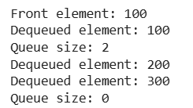

**Explanantion:**

* The Queue class follows the FIFO (First In First Out) principle.
* It uses a Python list to store elements internally.
* The enqueue() method adds elements to the rear using append().
* The dequeue() method removes elements from the front using pop(0).
* The peek() method shows the front element without removing it.
* The size() method returns the total number of elements in the queue.

**Task 3: Linked List**

**Prompt:**

Generate a Python implementation of a Singly Linked List with Node and LinkedList classes. Include insert and display methods with proper docstrings and demonstration output.

**Code:**

class Node:

    """

    A class to represent a node in a singly linked list.

    """

    def __init__(self, data):

        """

        Initialize node with data and next pointer.

        :param data: Value to store in the node

        """

        self.data = data

        self.next = None

class LinkedList:

    """

    A class to represent a Singly Linked List.

    """

    def __init__(self):

        """Initialize an empty linked list."""

        self.head = None

    def insert(self, data):

        """

        Insert a new node at the end of the linked list.

        :param data: Value to be inserted

        """

        new_node = Node(data)

        if self.head is None:

            self.head = new_node

        else:

            temp = self.head

            while temp.next:

                temp = temp.next

            temp.next = new_node

    def display(self):

        """

        Display all elements in the linked list.

        """

        temp = self.head

        while temp:

            print(temp.data, end=" -> ")

            temp = temp.next

        print("None")

# ------------------ Testing the Linked List ------------------

ll = LinkedList()

ll.insert(5)

ll.insert(10)

ll.insert(15)

print("Linked List Elements:")

ll.display()

**Sample Input\Output:**



**Explanantion:**

* The Node class represents each element in the linked list, storing data and a reference to the next node.
* The LinkedList class manages the list using a head pointer.
* The insert() method adds a new node at the end of the list.
* If the list is empty, the new node becomes the head.
* The display() method traverses the list and prints elements in sequence.
* The structure follows a dynamic memory approach unlike lists with fixed indexing.

**Task 4: Hash Table**

**Prompt:**

Generate a Python HashTable class implementing insert, search, and delete methods using collision handling with chaining. Include proper docstrings and demonstrate functionality with sample output.

**Code:**

class HashTable:

"""

A class to represent a Hash Table using chaining

for collision handling.

"""

def __init__(self, size=10):

"""

Initialize hash table with given size.

:param size: Number of buckets

"""

self.size = size

self.table = [[] for _ in range(size)]

def _hash(self, key):

"""

Private method to generate hash index.

:param key: Key to hash

:return: Index position

"""

return hash(key) % self.size

def insert(self, key, value):

"""

Insert a key-value pair into the hash table.

If key already exists, update its value.

"""

index = self._hash(key)

bucket = self.table[index]

for pair in bucket:

if pair[0] == key:

pair[1] = value

return

bucket.append([key, value])

def search(self, key):

"""

Search for a key in the hash table.

:return: Value if found, else None

"""

index = self._hash(key)

bucket = self.table[index]

for pair in bucket:

if pair[0] == key:

return pair[1]

return None

def delete(self, key):

"""

Delete a key-value pair from the hash table.

:return: True if deleted, else False

"""

index = self._hash(key)

bucket = self.table[index]

for i, pair in enumerate(bucket):

if pair[0] == key:

bucket.pop(i)

return True

return False

# ------------------ Testing the Hash Table ------------------

ht = HashTable(5)

ht.insert("101", "Alice")

ht.insert("102", "Bob")

ht.insert("103", "Charlie")

print("Search 102:", ht.search("102"))

print("Delete 102:", ht.delete("102"))

print("Search 102 after deletion:", ht.search("102"))

**Sample Input\Output:**

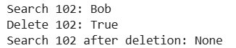

**Explanantion:**

* The hash table uses an array of lists (buckets) to handle collisions using chaining.
* The _hash() function computes the index using Python’s built-in hash() function.
* The insert() method adds key-value pairs or updates existing keys.
* The search() method looks for a key inside its bucket.
* The delete() method removes the key-value pair if found.
* Chaining ensures multiple keys can exist at the same index safely.

**Task 5: Graph Representation**

**Prompt:**

Generate a Python Graph class implemented using an adjacency list.  
Include add_vertex, add_edge, and display methods with proper docstrings and sample output.

**Code:**

class Graph:

"""

A class to represent a Graph using an adjacency list.

"""

def __init__(self):

"""

Initialize an empty graph with an adjacency list.

"""

self.adj_list = {}

def add_vertex(self, vertex):

"""

Add a new vertex to the graph.

:param vertex: The vertex to add

"""

if vertex not in self.adj_list:

self.adj_list[vertex] = []

def add_edge(self, vertex1, vertex2):

"""

Add an edge between two vertices (Undirected Graph).

:param vertex1: First vertex

:param vertex2: Second vertex

"""

if vertex1 not in self.adj_list:

self.add_vertex(vertex1)

if vertex2 not in self.adj_list:

self.add_vertex(vertex2)

self.adj_list[vertex1].append(vertex2)

self.adj_list[vertex2].append(vertex1)

def display(self):

"""

Display the adjacency list representation of the graph.

"""

for vertex in self.adj_list:

print(f"{vertex} -> {self.adj_list[vertex]}")

# ------------------ Testing the Graph ------------------

g = Graph()

g.add_vertex("A")

g.add_vertex("B")

g.add_vertex("C")

g.add_edge("A", "B")

g.add_edge("A", "C")

print("Graph Representation (Adjacency List):")

g.display()

**Sample Input\Output:**

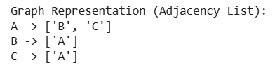

**Explanantion:**

* The graph is implemented using a **dictionary**, where each key is a vertex.
* The value of each key is a list representing adjacent vertices (Adjacency List).
* add_vertex() adds a new vertex if it doesn’t already exist.
* add_edge() connects two vertices (undirected connection).
* display() prints the full adjacency list representation.
* This approach is memory-efficient compared to adjacency matrix.

**Task 6: Smart Hospital Management System Data Structure Selection**

**Prompt:**

Generate a Python program to implement Emergency Case Handling using a Priority Queue. Critical patients must be treated first, include docstrings and demonstration output.

**Code:**

import heapq

class EmergencyQueue:

    """

    A class to manage emergency patients using a Priority Queue.

    Lower priority number means higher priority.

    """

    def __init__(self):

        """Initialize an empty priority queue."""

        self.queue = []

    def add_patient(self, name, priority):

        """

        Add a patient to the emergency queue.

        :param name: Patient name

        :param priority: Priority level (lower value = higher priority)

        """

        heapq.heappush(self.queue, (priority, name))

    def treat_patient(self):

        """

        Treat the highest priority patient.

        :return: Name of treated patient

        """

        if not self.queue:

            return "No patients in queue."

        priority, name = heapq.heappop(self.queue)

        return f"Treating patient: {name} (Priority {priority})"

    def display_queue(self):

        """Display current patients in queue."""

        print("Current Emergency Queue:")

        for patient in sorted(self.queue):

            print(f"Patient: {patient[1]}, Priority: {patient[0]}")

# ------------------ Testing the System ------------------

eq = EmergencyQueue()

eq.add_patient("Ravi", 3)

eq.add_patient("Anita", 1)   # Critical

eq.add_patient("Kiran", 2)

eq.display_queue()

print(eq.treat_patient())

print(eq.treat_patient())

print(eq.treat_patient())

print(eq.treat_patient())

**Sample Input\Output:**

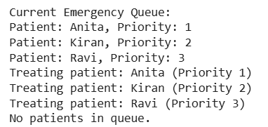

**Explanantion:**

|  |  |  |
| --- | --- | --- |
| **Feature** | **Selected Data Structure** | **Justification** |
| Patient Check-In System | **Queue** | Patients are treated in the order they arrive. Queue follows FIFO (First In First Out), making it ideal for registration and treatment sequence handling. |
| Emergency Case Handling | **Priority Queue** | Critical patients must be treated first regardless of arrival time. Priority Queue ensures higher-priority cases are processed before normal cases. |
| Medical Records Storage | **Hash Table** | Patient records need fast retrieval using ID. Hash Table provides O(1) average time complexity for search operations. |
| Doctor Appointment Scheduling | **Binary Search Tree (BST)** | Appointments sorted by time require ordered data. BST maintains sorted structure and allows efficient insertion and retrieval. |
| Hospital Room Navigation | **Graph** | Rooms and wards are connected like nodes in a network. Graph efficiently represents connections and navigation paths. |

* A **Priority Queue** is implemented using Python’s heapq module.
* Patients are inserted with a priority value where smaller numbers mean higher urgency.
* The add_patient() method inserts patients into the heap.
* The treat_patient() method removes the highest priority patient first.
* This ensures emergency cases are treated before normal cases.
* Time complexity for insertion and removal is O(log n), making it efficient.

**Task 7: Smart City Traffic Control System**

**Prompt:**

Generate a Python program to implement a Traffic Signal Queue using FIFO principle. Include proper docstrings and demonstrate vehicle enqueue and dequeue operations with output.

**Code:**

class TrafficSignalQueue:

"""

A class to manage vehicles at a traffic signal using Queue (FIFO).

"""

def __init__(self):

"""Initialize an empty traffic queue."""

self.queue = []

def add_vehicle(self, vehicle_number):

"""

Add a vehicle to the traffic queue.

:param vehicle_number: Registration number of vehicle

"""

self.queue.append(vehicle_number)

def allow_vehicle(self):

"""

Allow the first vehicle to pass the signal.

:return: Vehicle number that passed

"""

if not self.queue:

return "No vehicles waiting."

return f"Vehicle passed: {self.queue.pop(0)}"

def display_queue(self):

"""Display vehicles currently waiting at the signal."""

print("Vehicles waiting at signal:")

for vehicle in self.queue:

print(vehicle)

# ------------------ Testing the System ------------------

ts = TrafficSignalQueue()

ts.add_vehicle("TS09AB1234")

ts.add_vehicle("TS08CD5678")

ts.add_vehicle("TS10EF9012")

ts.display_queue()

print(ts.allow_vehicle())

print(ts.allow_vehicle())

print(ts.allow_vehicle())

print(ts.allow_vehicle())

**Sample Input\Output:**

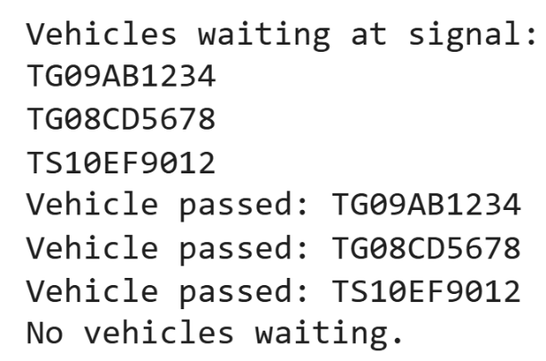

**Explanantion:**

* The Traffic Signal Queue is implemented using a Python list following FIFO order.
* Vehicles are added using append() to simulate arrival at the signal.
* The allow_vehicle() method removes vehicles using pop(0) to allow the first vehicle to pass.
* This ensures vehicles move in the same order they arrived.
* The system models real-world traffic flow logic.
* Queue operations maintain fairness and systematic movement.

**Task 8: Smart E-Commerce Platform – Data Structure Challenge**

**Prompt:**

Generate a Python program to implement an Order Processing System using Queue (FIFO). Include proper docstrings and demonstrate order placement and processing with output.

**Code:**

class OrderQueue:

"""

A class to manage customer orders using Queue (FIFO principle).

"""

def __init__(self):

"""Initialize an empty order queue."""

self.orders = []

def place_order(self, order_id):

"""

Add a new order to the queue.

:param order_id: Unique ID of the order

"""

self.orders.append(order_id)

print(f"Order placed: {order_id}")

def process_order(self):

"""

Process the earliest placed order.

:return: Processed order ID

"""

if not self.orders:

return "No orders to process."

order = self.orders.pop(0)

return f"Order processed: {order}"

def display_orders(self):

"""Display all pending orders."""

print("Pending Orders:")

for order in self.orders:

print(order)

# ------------------ Testing the System ------------------

oq = OrderQueue()

oq.place_order("ORD101")

oq.place_order("ORD102")

oq.place_order("ORD103")

oq.display_orders()

print(oq.process_order())

print(oq.process_order())

print(oq.process_order())

print(oq.process_order())

**Sample Input\Output:**

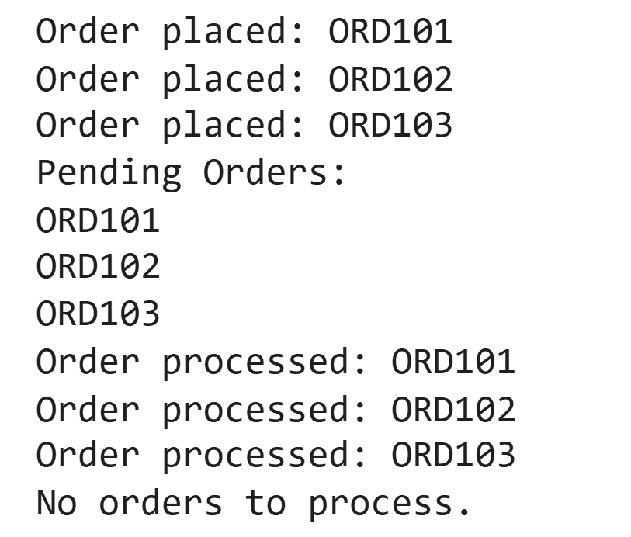

**Explanantion:**

|  |  |  |
| --- | --- | --- |
| **Feature** | **Selected Data Structure** | **Justification** |
| Shopping Cart Management | **Linked List** | Products are added and removed dynamically. Linked List allows efficient insertion and deletion without shifting elements. |
| Order Processing System | **Queue** | Orders must be processed in the order they are placed. Queue follows FIFO, making it ideal for order handling. |
| Top-Selling Products Tracker | **Priority Queue** | Products ranked by sales count require highest sales first. Priority Queue efficiently maintains sorted order based on priority. |
| Product Search Engine | **Hash Table** | Fast lookup using Product ID requires constant-time access. Hash Table provides O(1) average search time. |
| Delivery Route Planning | **Graph** | Warehouses and delivery locations are connected like a network. Graph models routes and paths effectively. |

* The Order Processing System uses a Queue to maintain FIFO order.
* Orders are added using append() which places them at the rear.
* Orders are processed using pop(0) which removes the first placed order.
* This ensures fairness and systematic processing.
* The implementation models real-world e-commerce order handling.
* The system remains simple and efficient for moderate-sized queues.